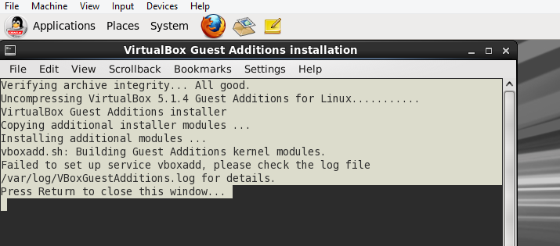

http://unixnme.blogspot.in/2016/11/how-to-install-virtualbox-guest.html

http://www.shayanderson.com/microsoft-windows/windows-10-host-install-virtualbox-5-1-4-with-centos-6-7-guest-with-shared-folders.htm

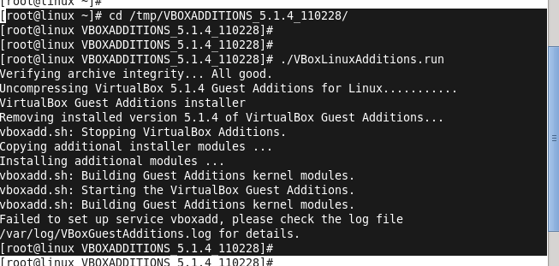

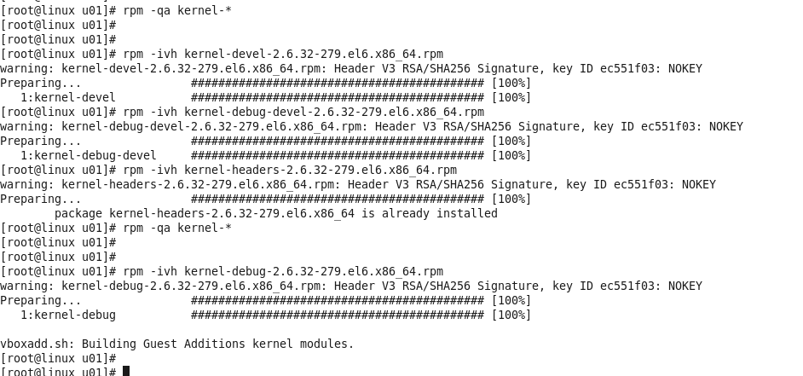

\

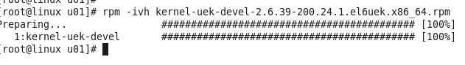

vnc issue -

https://support.realvnc.com/knowledgebase/article/View/241/1/timed-out-waiting-for-a-response-from-the-host-computer